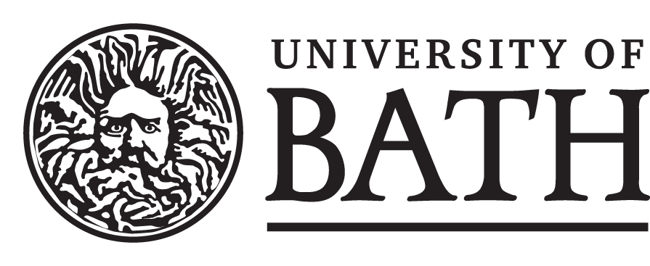

**Department of Economics**

**STUDENT & UNIT DETAILS –** TO BE COMPLETED BY THE STUDENT

|  |  |
| --- | --- |
| **Candidate Number** |  |
| **Unit Name and Code** |  |

**DECLARATION –** PLEASE READ CAREFULLY

When you enrolled as a student at the University of Bath, you agreed to abide by the University’s rules and regulations and agreed that you would access and read your programme handbook. This handbook contains references to, and penalties for, unfair practices such as collusion, plagiarism, fabrication or falsification. The University’s Quality Assurance Code of Practice, [QA53 Examination and Assessment Offences](https://www.bath.ac.uk/publications/qa53-examination-and-assessment-offences/), sets out the consequences of committing an offence and the penalties that might be applied.

**By submitting this assessment, you confirm that:**

1. You have not impersonated, or allowed yourself to be impersonated by, any person for the purposes of this assessment.
2. This assessment is your original work and no part of it has been copied from any other source except where due acknowledgement is made.
3. You have not previously submitted this work for any other unit/course.
4. You give permission for your assessment response to be reproduced, communicated, compared and archived for plagiarism detection, benchmarking or educational purposes.
5. You understand that plagiarism is the presentation of the work, idea or creation of another person as though it is your own. It is a form of cheating and is a very serious academic offence that may lead to disciplinary action.
6. No part of this assessment has been produced for, or communicated to, you by any other person.

|  |  |
| --- | --- |
| **MARK AND COMMENTS** – TO BE COMPLETED BY THE MARKER | |
|  |  |
| MARK (%) |

**START YOUR ASSESSMENT HERE.**

**BEFORE YOUR ANSWERS, STATE EXPLICITLY WHICH PART / QUESTION / SUBQUESTION YOU ARE ATTEMPTING.**